Addendum #1
Issue Date: 08.01.19
General Clarifications:
- This project is not tax exempt
- This project is not prevailing wage
- Bid date remains unchanged
Plan detail changes:
- Wherever the plan details call for a haunch to be installed in lieu of extending the exterior face of wall down to top of footing is not required. If it is more economical for this installation to extend down to top of footing this is accepted. See detail below.
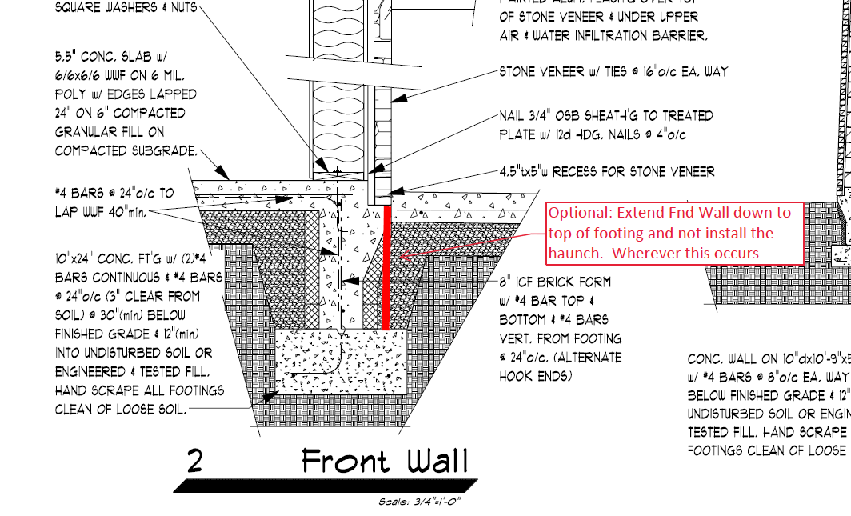

- Remove the rigid insluation that is called to be installed behind all metal siding. Horizontal 1 x lumber girts are to be installed 2ft on center for the full height of wall. See detail below
- Remove the 8” ICF brick form from the scope of work in its entirety. See detail below.
